

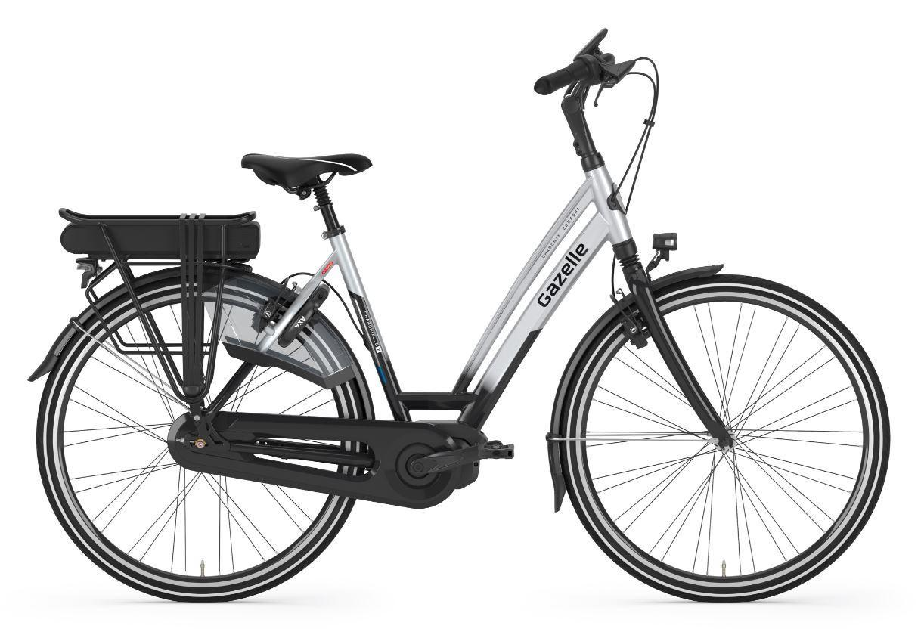

# Introduction & clients situation

## What is Gazelle?

Gazelle has been making bikes perfect for 125 years there: as light, qualitatively and comfortably as possible. They always think about how they can make our design smarter and our technology not more innovative. Familiar quality, modern luxury: you can be seen with a Gazelle bike!

## What does the client want?

|  |  |  |  |  |  |  |  |  |
| --- | --- | --- | --- | --- | --- | --- | --- | --- |
| **Client request** |  | **My contribution** |  | **Pros** |  | **Cons** |  | **Solution** |
| Promote E-bikes |  | Play on a e-bike |  | You’ll get used to how it rides |  | Can only be played at the experience centre |  | Don’t use the bike as controller, just use phone/mouse & keyboard |
| Give it a little competition (win a e-bike) |  | A game made based on score/time (maybe some sort of race) |  | People will play it more for a better chance to win the e-bike |  | It’s very easy to play, which can become boring over time |  | Make every game feel like a new one, but don’t make it too random (because it’s a game based on score/time and not luck) |

|  |  |  |  |  |  |  |
| --- | --- | --- | --- | --- | --- | --- |
| **Concepts** |  | **Pros** |  | **Cons** |  | **Solution** |
| 1. Cycler |  | Promotes biked |  | Is only available if you already own a bike |  | Make it also able to be used when walking |
| 1. **Bike dash** |  | **Fun to play, lots of competition** |  | **Tournament style, so you’re sort of stuck later on a schedule (for finals etc)** |  | **Do the (quarter) finals in an experience centre on one of the available dates, and let players who go into the (quarter) finals know the dates far in advance** |
| 1. Cycle simulation |  | Learns about the bikes available |  | You can’t make it competitive |  | It’s easier for people to test online than go to the store so I think that will already be enough to get sales going |

### Concept explanation

1. You’ll play the game on your own bike, by cycling trough the city the app will give you a route of specific kilometers and tracks if you finished the route. After every route you get a new one and whoever finished the most routes wins.
2. **You’ll create your own bike in the customization screen, with it’s own engine, color etc. And then you’ll race against each other and use items to stop each other. It’s tournament style, so the 1st and 2nd place will move forward in the competition and in the last round the winner wins the bike that they created.**
3. Make your own bike with all the specs that are available on the bikes and take it for a test drive in the game to see how it feels.

# Boundaries

## When will we start and when will it be done?

I start right away with the project. We have a deadline each 2 weeks to show some progress of the game. This will also be the moment where the client can give notes on changes and things that they want to be added. The dates will be set at the end of the first meeting, if somehow one of the parties can’t make it they’ll need to let it know at least a 3 days in advance. ( When possible )

Since we have only 3 months we’ll have to work hard and fast to create something good looking and fun.

(about 12 weeks )

|  |  |  |  |  |
| --- | --- | --- | --- | --- |
| **Week** |  | **What we want to achieve** |  | **Date of meeting with client** |
| 1 |  | Create player movement + player art [recolor] |  |  |
| 2 |  | Create a basic [test] level + work on level art |  |  |
| 3 |  | Create drift motions + speed boosts + create items |  |  |
| 4 |  | Create waypoints [respawn] + search audio |  |  |
| 5 |  | Collision + create menu art |  |  |
| 6 |  | Create a menu + User Interface |  |  |
| 7 |  | Create Item block with random item |  |  |
| 8 |  | Create player selection |  |  |
| 9 |  | Create a position tracker |  |  |
| 10 |  | Create minmap + add audio |  |  |
| 11 |  | Create customizable players/bikes |  |  |
| 12 |  | Create customizable constrols |  |  |

# Budget

We have a budget of €40.000-,.

## What will be the cost?

I will work 8 hours a day 5 days a week, I start at 8:30 am till 5:00 with half an hour break.

breaks will not be charged.

I work for €50-, an hour, so that will be a total of €375 a day.

I also have some accommodations that the client will have to pay for, this does not include my paycheck.

Since we’ll only be able to have a team of 4 a lot of the team members need to take on other roles.

The *highlighted* roles are the roles we’ll defiantly need, they can also take on the roles that are left.

|  |  |  |  |  |  |  |  |  |
| --- | --- | --- | --- | --- | --- | --- | --- | --- |
| **Roles needed** |  | **Why?** |  | **How long needed** |  | **Cost per hour** |  | **Total cost** |
| Audio design |  | Every good game has music in it |  | 1 week |  | €45-, an hour |  | €1.800-, |
| *Art* (2) |  | We need to make it look pretty |  | 3 months |  | €40-, an hour |  | €7.680-, |
| *Development* (2) |  | We need someone to make the game |  | 3 months |  | €50-, an hour |  | €9.600-, |
| Play tester |  | We need some feedback from outside to make sure it’s fun to play |  | 3 days |  | €30-, an hour |  | €720-, |
| Project manager |  | We need someone to make plans and make sure everything goes as plan |  | 3 months |  | €60-, an hour |  | €5.760 |
|  |  |  |  |  |  |  |  | **Total : €25.561** |

I also have some accommodations that the client will have to pay for.

(this does not include my paycheck)

|  |  |  |  |  |
| --- | --- | --- | --- | --- |
| **Accommodation** |  | **Usage** |  | **Cost** |
| Unity pro |  | This is where I will make the game in |  | €125 /month  €1.500 / year |
| Maya 2018 (optional) |  | I will make the models in here |  | €242 / month  €1.936 / year |
| Photoshop |  | I will make the design and textures in here |  | €24,19 / month  €290,17 / year |
|  |  |  |  |  |
|  |  |  |  | **Total: €319,19 / month**  **€ 3.726,17/ year** |

Since we’ll only work on this for 3 months the cost would be **€957,57**

Not including Maya 2018 will make it drop down to **€591,71**

Team cost ( 2 artists & 2 Developers ) **€17.280**

All the cost together ( Team costs & with Maya ) would be a total of **€18.237,57**

All the cost together ( Team costs & without Maya ) would be a total of **€17.871,71**

**Source:** [**https://store.unity.com/**](https://store.unity.com/)**,**

[**https://www.autodesk.nl/products/maya/subscribe?plc=MAYA&term=1-YEAR&support=ADVANCED&quantity=1**](https://www.autodesk.nl/products/maya/subscribe?plc=MAYA&term=1-YEAR&support=ADVANCED&quantity=1)**,** [**https://www.adobe.com/nl/creativecloud/plans.html?single_app=photoshop&promoid=KSPCO&mv=other**](https://www.adobe.com/nl/creativecloud/plans.html?single_app=photoshop&promoid=KSPCO&mv=other)